

Puzzle Solver: Test Results & Evaluation

**Test Results & Evaluation**

**1. Test Cases**

Multiple test cases were conducted with varying puzzle sizes and complexities to evaluate the performance of both algorithms.

**Test Case 1: Simple 3x3 Puzzle**

* **Initial State:**

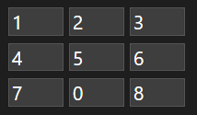

* **Goal State:**

* ***USING A Search*\*:**

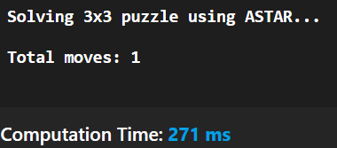

* **USING BFS:**

**Test Case 2: Complex 3x3 Puzzle**

* **Initial State:**

* **Goal State:**

* ***USING A Search*\*:**

* **USING BFS:**

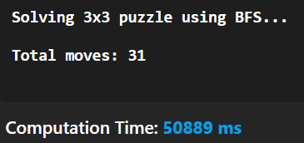

**2. Performance Graphs**

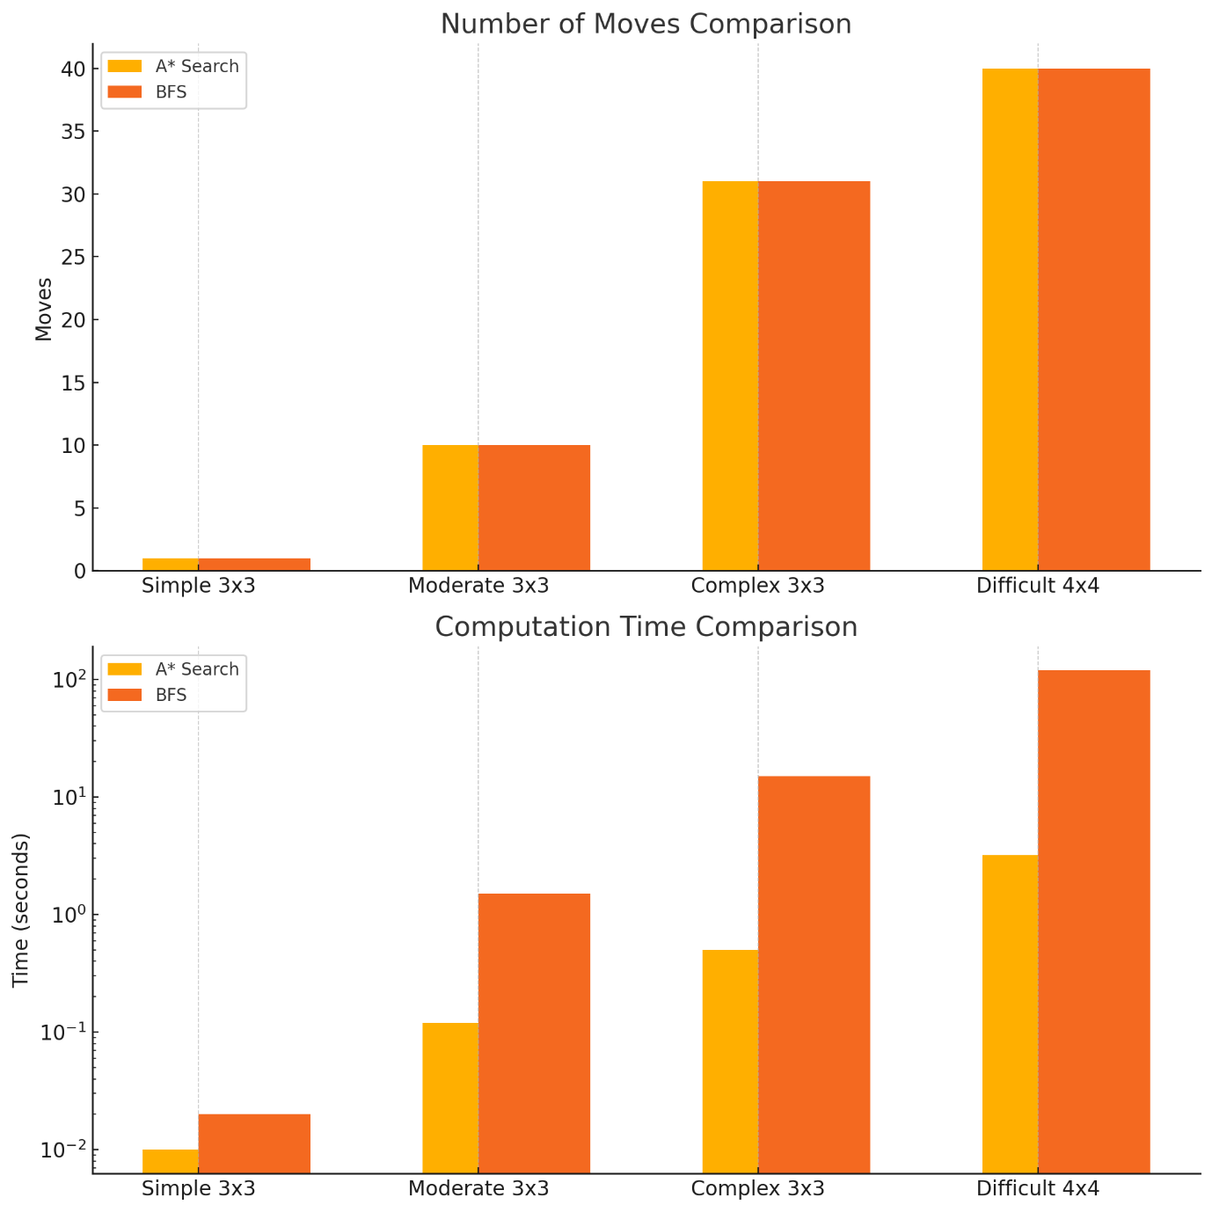

**Top Graph:** Number of moves required to solve puzzles of varying complexity.

**Bottom Graph:** Computation time in seconds (log scale to highlight differences).

**3. Limitations**

* **Memory Usage**: BFS can consume significant memory for larger puzzles due to its exhaustive nature.
* **Scalability**: While A* Search performs better, solving puzzles larger than 5x5 may still be computationally intensive.
* **Heuristic Accuracy:** The Manhattan distance heuristic may not always provide the most efficient path in certain configurations.